Domain analysis

1/The need for the application:

# Problem Definition

Nowadays, social media has become more and more accessible,it’s a platform for user to interact with each other and share their stories.In addition,its also a place for various user’ groups to advertise their brands and products,which in terms of business perspective is a great way for self promotion,one of the groups is artist.However,i believe there are several problems that artists on social media have to overcome.Firstly,artists ,who are new on a social media platform, are likely to have a small chance of being recognized.Secondly,one of the main problem with artists is that they have to work constantly for a long period of time without resting,this could lead to stress and eventually cause art block.Lastly,most platform that allows artists to sell their products tends to be very competitive,especially for new artists on the platform.I believe these problems can be crucial disadvantages because they might keep new artists from advertising and selling their works on-line,restrict freedom in creativity which is important for artistic development and drain inspiration from artists.

First of all,new artists tends to struggle with being recognized.The reason for this is social media application’s discovery tab tends to features trending and popular posts and if there are too many of those, new posts are likely going to be less approachable,thus making the platform feel very competitive and put a lot of pressure on artists.According to an article by Sophie Porter(2019),there are many companies all over the world that invest in advertising their products on social media and this results in other smaller social media profiles being neglected,which likely make it harder to grow an audience.However,there are platforms such as “artstation” that can help artists solve this problem since it provides a chance for new posts to get more engagement using its “latest tab” while still provide users with trending and popular posts and products.

Second of all,the job of an artists usually might require a high level of focus for a long period of time, this can be very stressful and might eventually drain artists’s motivation and inspiration,which could lead to art block.In an article by ingrid Christensen(2019),despite having well structured ideas,_artists often might feel helpless and less confident in there artwork sometime due to artblock because of many reasons:it could be that they are working under pressure or sometime there is no reasons at all.This could be very challenging for artist as it slows down working process.One of the way i believe could solve this problem is to take inspiration for other artists and platform like “ArtStation”,”Instagram” are great sources due to many amazing artists on the platform.It is also suggested by Hans Christian Andersen(pencilkings.com) that listening to music might also inspire artists because you are “drawing inspiration from what you hear”.Application such as “Spotify” is a great sources for musics as it also provide list of songs based on mood.Based on a blog by artworkarchive,Instagram is one of the good source of inspiration in terms of art,it is reported that more than half of art collectors buy their arts from artists they found through instagram.

Finally, social media can be very competitive ,because of this,artists ,in order to to sell their products they have to be relevant on a platform, this means artists have to adapt the algorithm of that specific platform ,which create constraints on their creativity.Based on an article on ruthmillington.co.uk,it is said the upcoming generation of artists are under the influence of “Instagram art” ,this means that they have to adapt to the way instagram works,which could cause the lost of freedom in creativity in the art industry.I believe one of the way to solve this problem is to provide a platform where there are variety in the type of artwork,such as: 2D,3D,concept art,landscape,portrait.... so that artists can find what they prefer.This could allow artists to freely come up there own artwork without being restricted with satisfying the website’s algorithm.One of the best site that have this feature is Artstation ,the website has assign each post with a type,such as : illustration,3D/2D art,character design,...,this might allow users to create and post any type of artwork they prefer without worrying about following the algorithm of the website.

In conclusion, there are 3 possible problems for artists on social media:having a audience,artblock/pressure and satisfying the platform’s algorithm.In order to solve these problems, platform such as Artstation,spotify, netflix ,... are essential as they provide entertainment,fairness,relaxation and are user-friendly.

Reference:

<https://www.artsy.net/article/artsy-editorial-5-ways-artists-overcome-creative-block>

<https://www.webkick.co.uk/blog/common-problems-with-social-media-marketing-how-to-overcome-them>

<https://www.pencilkings.com/inspiration-for-drawing/>

<https://ruthmillington.co.uk/is-social-media-ruining-art/>

2/User roles or Personas:

-Artists(singer/painter):

These users use the system for posting and selling their artwork.Professional artists can build their own portfolio and organize it the way they want.This could be a great method for advertising your skills and get a higher chance of being hired by recruiters.User would not have to consider understanding the platform algorithm to adjust their work because artworks are categorised and users can choose to display what category they prefer.New users will have an easier time to get their works displayed to the public as the system will provide a tab for latest trending artworks,due to this ,other latest artworks might be discovered easier.The system also provide music/movies recommendation based on the user mood by monitoring their behaviour and users can host a competition with a certain topic that last for a week.Because of this, users can become inspired and relieve stress from long hours of working,they are also provided with many popular/professional artworks posted by other users as inspiration.

3/Similar Products:

Artstation is a professional website for creating your own portfolio and on-line store to sell artworks.In addition ,it is also a platform for recruiters to find suitable candidate for their company as the site tends to focus on professional artist’s works and has a lots of users who are working for big companies in the art industry.

Advantages:

|  |  |  |  |
| --- | --- | --- | --- |
| **Identified Problems** | Difficult to sell/share artworks due to not being recognised | Has to follow a platform algorithm to get the post trending,cause restriction in creativity | Art-block and stress from working for long hours and competitive environment |
| **Solution** | -A platform for professional artists ,thus easier for recruiter to find candidates for their company and for artists, a higher chance of being hired  -User can create their own portfolio for advertising their works and specify the category for their works  -Provide a latest tab for showcasing new posts,this is a chance for new to be recognised and advertise their skills | -Has a variety of category of artworks so artists can display what they prefer to see,this means artists only have to worry about their ability and work instead of understanding how the page work. | -The explore page of the platform always showcase the trending artwork from professional artists ,this can be a good source of inspiration not only for newcomers but also other professional artists  -The site provide challenges to create artwork about a certain topic for artists who wants a good competition ,this can keep artists motivated and inspire their creativity or act as a chance for studying new ideas and techniques,thus might eliminate art-block |

Cons:

|  |  |  |  |
| --- | --- | --- | --- |
| **Identified Problems** | Difficult to sell/share artworks due to not being recognised | Has to follow a platform algorithm to get the post trending,cause restriction in creativity | Art-block and stress from working for long hours and competitive environment |
| **disadvantages** | -Since this a site for professional artists ,it is hard for new artists to advertise their because trending and popular arts is preferred.This also gives new artists a hard time to advertise their works,causing them to lose inspiration or stress. |  | -Since this is a site for professional artists, it could also be a competitive environment because not only recruiters but also average users prefer to see highly polished artworks,this might gives artists a standard that they believe that have to reach so that they know that they had improved,this can be a benefit since this helps artists learn new skills and advance as an artist.However, this also might causes stress when the artist can reach that standard ,thus putting them under pressure,which might reduce the quality of their work |

4/Task for each user(what users use the software for?):

Artist:

* +Buying: artist can artworks from another artist’s shop
* +Edit their profile’s information/gallery/Saved posts /shop
* +Post images/videos to gallery
* +Like/Save/share another artist’s posts
* +Add artworks for sale to shop
* Get inspiration recommended by the system

5/Domain model

User

Homepage

Gallery

Shop

Followers Page

Following Page

Saved Posts

Information Page

Post

Artwork

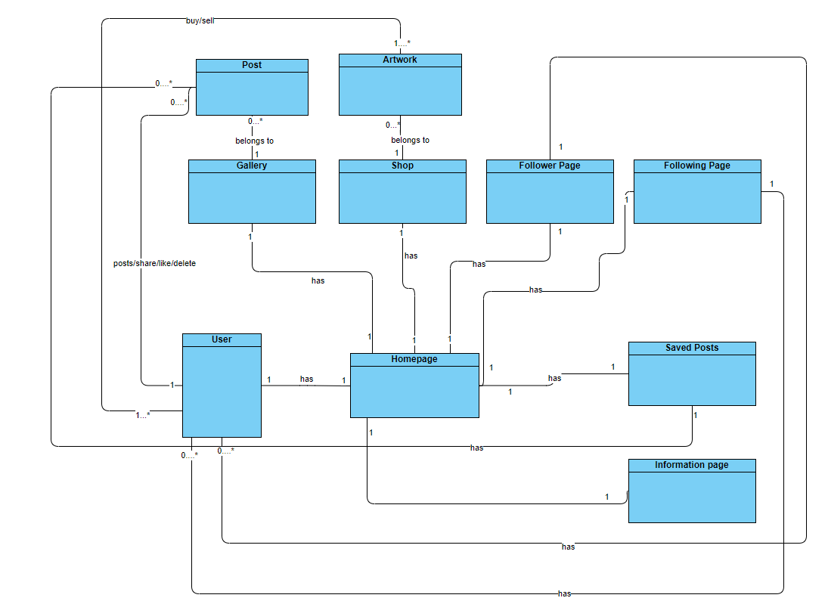

Requirement:

|  |  |  |  |
| --- | --- | --- | --- |
| ID | Functional Requirement | Priority | Actors |
| General | | | |
| 1 | System ‘s home page show images of user’s followers | Must | user |
| 2 | System has a discovery tab to show trending/latest/follower’s images | Must | user |
| 7 | System must has a homepage for each user |  |  |
| 8 | System has database for storing user accounts |  |  |
| 9 | System has database for storing posts and their information(images and videos) |  |  |
| 10 | System has database for storing artworks and their information |  |  |
| 11 | System must have a search bar to search for any type of content on the site from post to artwork |  |  |
| 12 | System must initially monitor the user ‘s mood by asking for their interest in art |  |  |
| 13 | System must initially ask user to decide whether they want to play music whenever they access the page |  |  |
| 14 | System must be able to play music corresponding to the user mood at any page of the site |  |  |
| 15 | User must be able to play/stop the music |  |  |
| 16 | User must be able to choose their own music |  |  |
| 17 | System must has 3 lists:trending this week/this month/latest |  |  |
| User | | | |
| 18 | User must be able to like,comment on posts |  |  |
| 19 | User must be able to save posts |  |  |
| 20 | User must be able to share posts to facebook/twitter |  |  |
| 21 | User must be able to follow other account |  |  |
| 22 | User must NOT be able to download a post with right-click operation |  |  |
| 23 | System must allow user to sign in |  |  |
| 24 | System must allow user to log in |  |  |
| 25 | System must allow user to log out |  |  |
| 26 | System must allow user to posts images/videos |  |  |
| 27 | System must allow user to buy artworks |  |  |
| 28 | System must allow user to add artwork for sale into their shop |  |  |
| 29 | System must be notified in real time |  |  |
| 30 | System must be able to view the discovery tab with specific interest such as : illustration,character design,fantasy,..... |  |  |
| 31 | User must be able to edit their profile |  |  |
|  | User must be able to start a challenge about a certain topic |  |  |
| User’s mood | | | |
| 32 | User must has a mood attribute to monitor their mood in 4 range:sad,normal ,happy,excited |  |  |
| 33 | User’s default mood is happy |  |  |
| 34 | User’s mood is changed by the type of images they click on |  |  |
| 35 | User’s mood affects the next song.The tab will play the next song corresponding to the mood |  |  |
| 36 | User’s mood affect the discovery tab.The tab will display images corresponding to the mood |  |  |
| Sign Up | | | |
| 37 | User is asked for their first name,last name,email,password,password confirmation ,occupation,where they are working,other information they would like to provide to their bio. |  |  |
| 38 | User is asked to choose their interest from a list |  |  |
| 39 | User is asked to write an About me summary and provide 3 pictures of their artwork |  |  |
| 40 | System must save into database the user’s firstname,lastname,email,password,occupation,working location,interest’s list,about me section and its 3 pictures and assign an ID number to the user |  |  |
| Login | | | |
| 41 | User must enter their user email ,password |  |  |
| 42 | System must validate those information with records from database |  |  |
| 43 | System must provide a message confirming the user that they have logged in successfully |  |  |
| 44 | System must provide a message confirming the user that they have logged in unsuccessfully |  |  |
| 45 | User must be able to logout |  |  |
| User’s Homepage | | | |
| 46 | Homepage has Gallery page storing user’s post |  |  |
| 46 | Homepage has Follower page showing who is following the user |  |  |
| 46 | Homepage has Following page showing who the user is following |  |  |
| 46 | Homepage has About me page storing user’s information including a summary and 3 pictures |  |  |
| 47 | Homepage has a Blog tab showing article written by the user |  |  |
| 47 | Homepage has a follow button for account that is no the user |  |  |
| 48 | Home page always display user’s name,occupation,working location,other information input by the user |  |  |
| Posting a post | | | |
| 49 | User must upload images or videos and write a summary |  |  |
| 50 | User must enter at least 1 type of interest the post belong to such as : illustration,3d moddeling ,2d art |  |  |
| 51 | System must determine the mood of the image by monitoring the Dominant Color of the image |  |  |
| Post | | | |
| 52 | A post must have these attribute:list of images(maximum 10),summary,number of like,currentInteraction(updated every hour),lastInteraction(updated with currentInteraction every hour) , number of comment,comments,mood,interest,the author.These must be stored in the database and assigned with the author’s ID |  |  |
| 53 | For user different from the post’s owner,there is a like/share/save button |  |  |
| 54 | Owner must have option to edit/delete the post |  |  |
| 55 | Owner while editing the post can delete/add images and change the summary ,once the images are changed,the post mood is updated.These information is then used to update the record in the database |  |  |
| Discovery tab | | | |
| 62 | The tab must show trending/latest/following posts |  |  |
| 63 | The tab must allow user to decide what type of post to show based on type of interest |  |  |
| 64 | The content shown must be based on the trending/latest/following filter, type of interest and the user mood |  |  |

Use Case Diagram:

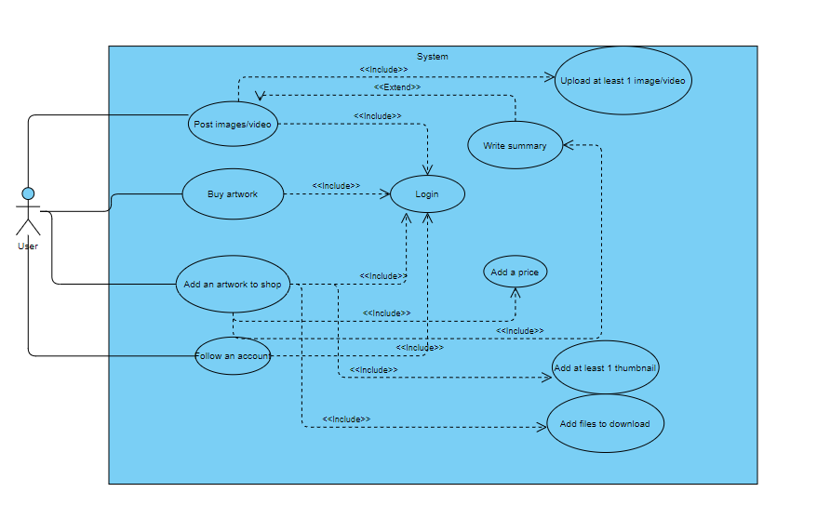

Class Diagram:

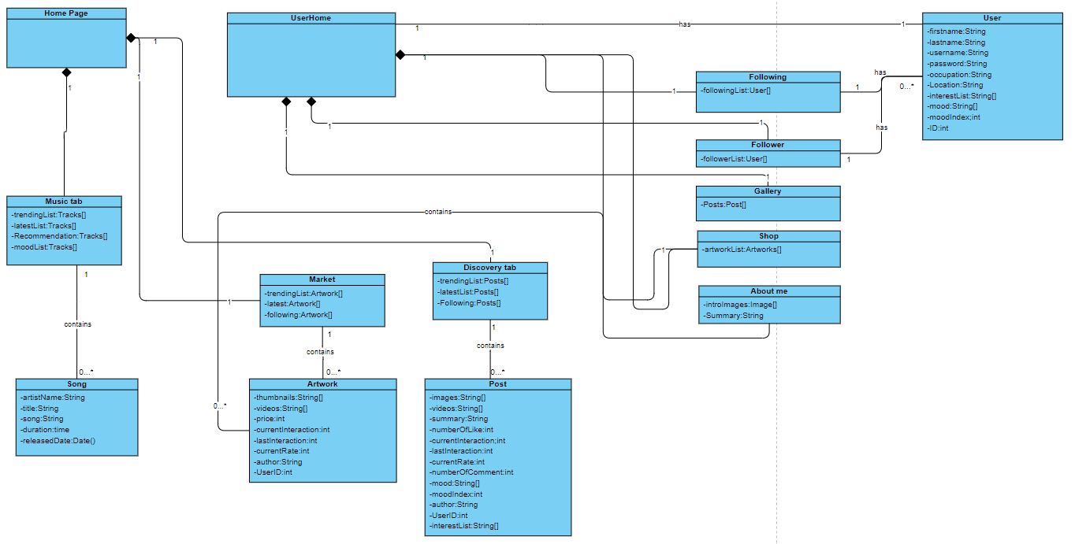

Plan:

<https://trello.com/b/OKoIBHZT/artnote>

MVP: Monitor an post and derive the mood,monitoring the user’s mood ,MVP,sharing platform

Milestone in plan(different types of activities)

Type of evaluation need to improve

Creativity Support Tools

Milestone in plan(different types of activities)

Type of evaluation need to improve